Meta Title:
Stair Design Installation Services & Products
Meta Description:
Upgrade your staircase with Houston Custom Carpets' professional stair design installation services and products. Get the finest quality. Shop now!

https://houstoncustomcarpets.com/products/stair-rods/ | stair design | 2.4k
 | Stair Rods | 1.6k
 | Zoroufy stair rods | 70

Professional Stair Design Services in Houston, TX

If you are in Houston and looking for custom stairs, Houston Custom Carpets is your solution. Our expert craftsmen and designers always consult with you to create the right final design that fits your style and taste. We offer various services & solutions as well as products that entail the homeowners, from installing committed stairs to refinishing hardwood stairs.

Take Your Home to the Next Level with a Classic Staircase:

The staircase in our homes is an important and central part of the structure as far as both aesthetics and practicality are concerned. Functional stairs today are not just a mere way to get from one floor to the other; they introduce sophistication and can potentially add extra value to your house. At Houston Custom Carpets, we value an elegant, classic staircase that fits the architecture of your house well.

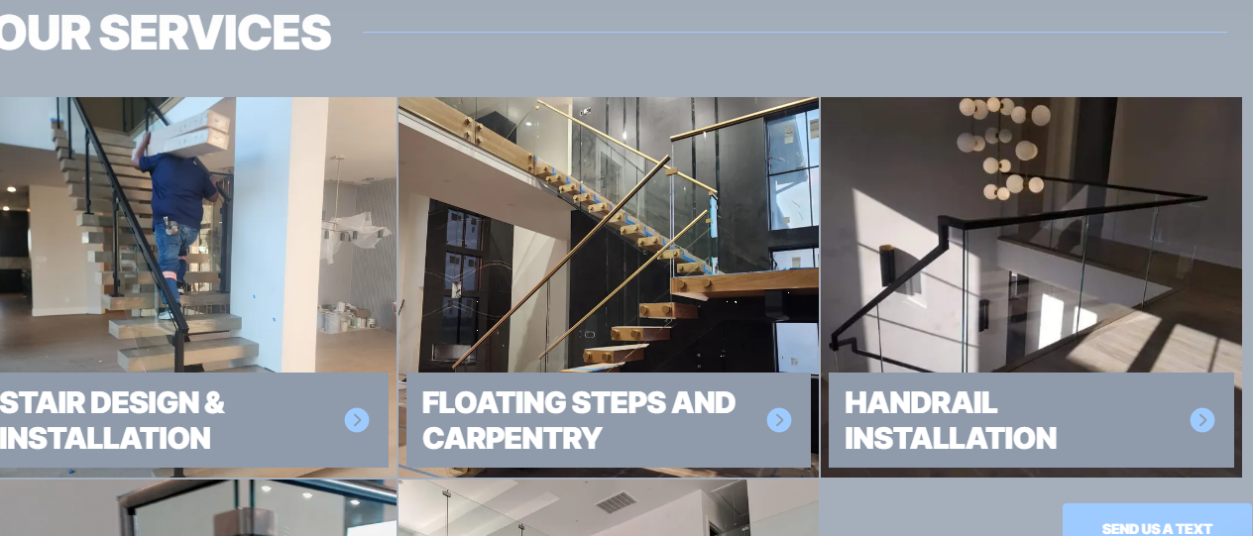Our Services::
If you want to transform your home with superior custom stair solutions and superior workmanship, then our staircase design services are the best option for you. Here is what you can expect from us:

Iron Baluster Installation | Stair Treads Installation | Refinish Wood Stairs
Our iron balusters are understandably well put together and are available in a wide selection of styles, including the basic to the fancy, and yes, your staircase will look spectacular with our iron balusters on it. Rest assured we have many colors, ranges, and types of material appropriate for your house. | Our experienced staff focuses on the installation of hardwood, carpet, or composite stair tread to ensure your new home possesses both beauty and strength. When it comes to choosing the right material, texture, colors, and overall look of your stone, we promise to be as picky with our stone as you are with your project. | Eventually, the wooden stairs tend to look worn out as well as faded. Depending on the current conditions of the sanitary, we can provide you with professional refinishing which will return back the stairs to its previous stunning look. Select from numerous different wood stains and finishes to achieve the appearance you want.

Professional staircase installation | Contemporary Stairs
Looking for a professional stair maker to install your stairs? Look no further; we install staircases and ensure they are done to the best standard. We guarantee to offer you professional services in the construction of your custom staircase that will meet the necessary and sufficient building codes and safety measures. | Design the future of the interiors with our stylish staircases: Whether you prefer your steelwork smooth and sophisticated with the use of glass and metal handrails or a more raw look achieved by using wooden treads and custom-designed baluster options, we will assist you in forging your dream of getting modern staircase.

Transform Your Space with High-Quality Custom Stair Parts & Accessories:
If you want to challenge the conventional notions of the staircase with modern & luxurious looks, then our Zoroufy stair rods products can help you out. From iron railing to Cable Railing. We have everything stored for you.

Iron Railing | Mono Stringers | Glass Railing
Iron bar upgrades the look of your staircase and is also resistant to wear and tear. At our company, we have many types of iron railing to meet all kinds of homes, from the conservative type homes to the contemporary type homes. Here at Houston Custom Carpets, we do not compromise on material and workmanship to ensure that your iron railing will last for many years to come. | Mono stringers are a current and elegant approach to your staircase. Our professional designers sit down with you to develop bespoke mono stringers for your home to suit the architectural design of your home. Our Offerings for the mono stringer come in a range of colors and utilize materials such as wood, stainless steel, or aluminum which makes your options endless. | Open glass railings look elegant and stylish and also let in plenty of light to open up the interior of the house. We also employ professional craftsmen who will assist you in coming up with the best glass railing most appropriate to your home. We’ll help you balance your style and decor objectives while selecting from the available glasses and finishes of your choice.

Horizontal Railing | Cable Railing
Horizontal railings are modern twists to conventional stair constructions that are worth seizing. This allows our expert designers to help you select appropriate horizontal railings that best suit your home’s design while meeting stairs requirements. Whether it’s painted or stainless steel, traditional or contemporary, the horizontal railing options are almost limitless. | Cable railings look a little more plain and sleek, and they provide the staircase a fresher and more light-hearted appearance. Our talented team of installation specialists and tradespeople sit down with you to discuss and determine the ideal cable railings for your home. The versatility of cable and post allows us to arrange all options with the elegance that you require.

FAQs

Which materials do you use in stair tread installation?
We are equipped with a variety of products that are used in stair tread installation such as hardwood, stones, and carpeting. Our team helps you identify the right material that matches your home and offers the best comfort and safety to your family.

How long does it take to install a set of stairs?
The time required for stair installation can, therefore, be greatly affected especially depending on the size and difficulty level of work. During the meeting, we explained to you all the timelines that we need to complete the project and give you a heads-up regarding any holds.

What can you make a match of stairscase design with the house’s design?
Of course, our expert designers complete the unique designs that agree with the rest of the home style. Of course, you may require a coordinated appearance; therefore, we work hard to provide a customized solution suitable for your home and architecture.

Do you provide a warranty on your products and services?
Yes, our custom stairs come with a warranty for the products and services, so you are assured of quality. The scope may vary from product to product, or service to service, so you should consult the terms of warranty with our team on the day of the first meeting.
